11.5

PROBLEM 1

4

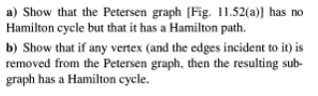

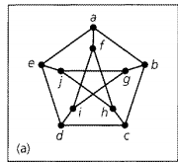

a/hamilton path: a->b->c->d->e->j->g->i->f->h

b/if we remove an inner point like f, we can have cycle

a->b->g->i->d->c->h->j->e->a ,successfully

if we remove a outer point like a, we can have cycle

f->h->c->b->g->j->e->d->i->f, successfully

PROBLEM2

14

Take problem 1 for example , there exists a hamilton path, however ,the sum of any two point'degree is 6, smaller than n-1 which is 9

PROBLEM 3

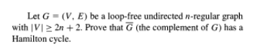

20

cause it is n-regular, and there are more than 2n+2 vertices ,

then for complement of G, the degree of every vertice will >= 2n+2-n=n+2 >(2n+2)/2=n+1, (collary 11.5) so it will the complement of G will have hamilton cycle.

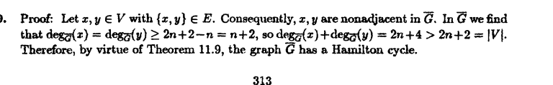

PROBLEM 4

22

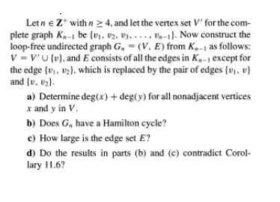.

so the change is add a new vertex ,and {v1 v2} is replaced by {v1v} {vv2}

a/ if x!=v, y!=v, then x and y must be v1 v2 if they want to be nonadjacent. Then deg(x)+deg(y)=deg(v1)+deg(v2)=2\*(n-2)=2n-4 // though edge {v1,v2} is lost, a new edge {v1v}/{v2v} is added

if x=v, y can be any point except a/b , then deg(x)+deg(y)= 2+n-2=n //2 is {v1v},{v2v}

b/

Yes, take any nonadjacent vertices, the sum of their degree >=n (theorem 11.9)

c/ for K(n-1): n\*(n-1)/2 ,then we remove one edge, add 2 edge, so the final answer is n\*(n-1)/2+1

d/ no. E= n\*(n-1)/2+1 and has hamilton cycle doesn't contradict corolary 11.6 (because 11.6 doesn't have if and only if)

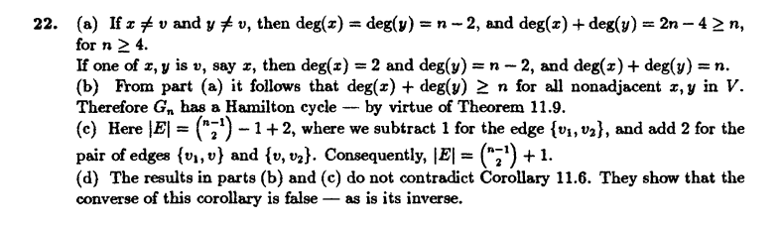

11.6

PROBLEM 5

8



part 1: if it is bipartite, and we divide the vertices to top side and bottom side, then just give top side one color, bottom side one color, ,true

part 2: if ,then we can only give vertices one color of two, if a vertice have first color, divide it to top side (set V1), if a vertice have second color, divide it to bottom side (set V2), cause there is no edge between vertices with same color, then it is bipartite.

Like this  
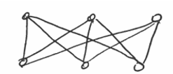

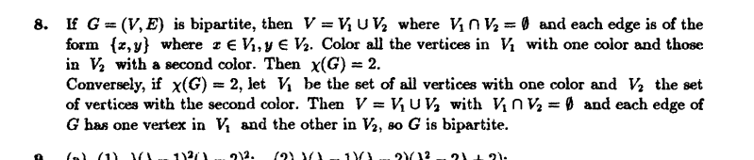

PROBLEM 6

12

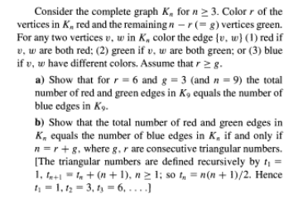

a/ red: 6\*5/2=15 //one vertex of 6 \* other 5 red vertex/ repeat

green: 3\*2/2=3 // one green vertex of 3\* other 3 green vertex/repeat

blue: 3\*6=18 // one green vertex of 3\* one red vertex of 6 (no repeat)

3+15=18

b/ blue= r\*g

red = r\*(r-1)/2  
 green= g\*(g-1)/2

cause we want blue=red+green

r\*g= r\*(r-1)/2+ g\*(g-1)/2

r^2-r+g^2-g-2gr=0

(r-g)^2 -r-g=0

cause r always >g ,assume r=g+k

k^2- 2g-k=0

g=(k^2-k)/2 =(k-1)k/2 which is triangular number

r=g+k= (k^2+k)/2= k(k+1)/2 which is next triangular number

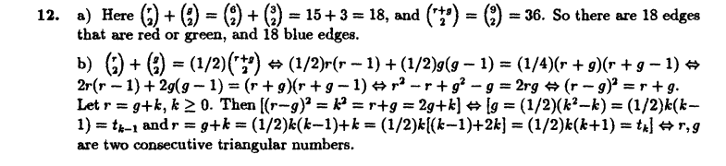

PROBLEM 7

14

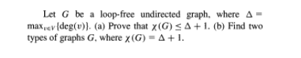

a/pick a vertex from the graph, we can there are most Δ vertices adjacent to it. Even all of them are different color, we can still pick the rest 1 from Δ+1 color. It is true for all vertices in G.

b/ K4/K5

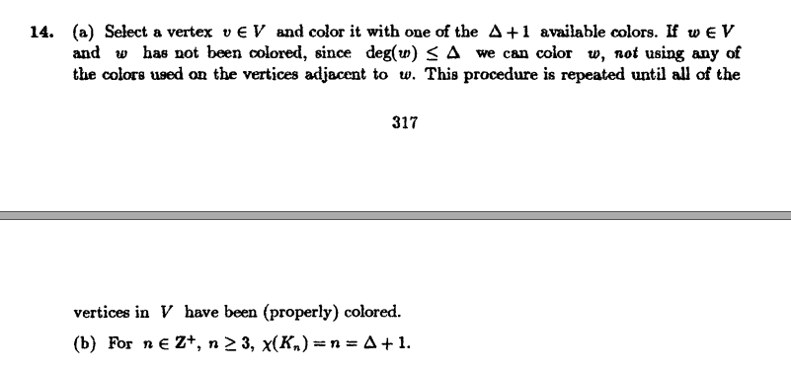

12.1

PROBLEM 8

8

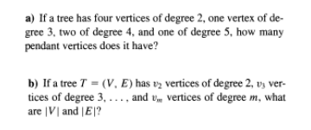

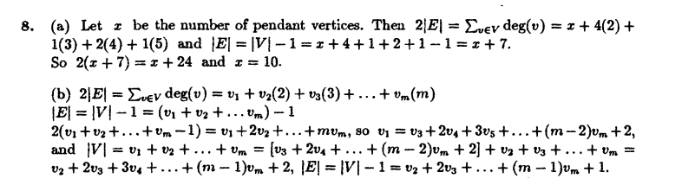

a/ let x= pendant tree which has degree 1

2E= x+8+3+8+5 =2V-2

X+24=2\*(x+4+1+2+1)-2=2x+14

x=10

b/

2E=v1+2v2+3v3+4v4+....mvm

E=V-1=v1+...vm-1

V=V1+V2+....VM

PROBLEM 9

10



31 (tree is the critical point between connected and disconnected)

PROBLEM 10

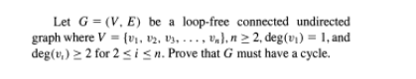

12



if G is connected undirected graph and also have no cycle, then G is a tree, then B must have at least two vertices whose degree is one, while ,contradiction

Problem 11



No, degV=2E, however 4+4+3+2+2 is not even

Problem 12



a tree has at least 2 leaves(pendant vertex) which degree both 1

Problem 13



A/if G is not connected , then G has at least 2 subgraphs, one have k vertices, then the rest one have n-k vertices.

Then the edge will be at most k(k-1)/2 + (n-k)(n-k-1)/2 //COMPLETE GRAPH

=k^2-k+n^2+k^2-2nk-n+k /2

=2k^2+n^2-2nk-n/2

n^2-n is constant， 2k^2-2nk<0

so to maximum edge, we need to maximum 2k^2-2nk

b^2-4ac=0, k should be -b/2a=0.5n

(1)then at most 1.5n^2- n^2-n/2 =0,5n^2-n/2=0.25n^2-0.5n

(2)=0.5n^2-1.5n+2

use (2) minus (1) = 0.25n^2 -n+2 , b^2-4ac=1-2<1, which means (2)minus (1) always >0

which means G is must connected because even the most of disconnected edges still cannot satisfy  , contradiction

B/based on question 1,

use (2) minus (1)=1

n^2-4n+4=0

n=2

so the answer is , the original graph is 2 vertices with one edge, the disconnected graph is 2 disconnected vertices

14.



a/ when m=n, 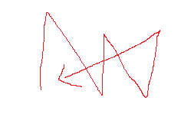in this way

b/ m=n+-1 or m=n